|  |  |  |
| --- | --- | --- |
|  | **Kingdom of Saudi Arabia**  **Ministry of Higher Education**  **King Faisal University**  **College of Computer Sciences & Information Technology** |  |

**King Faisal University**

**Collage Of Computer Science & Information Technology**

**Advance of software engineering**

**Group: 2**

**ASE project Report**

**title:**

**[inventory system]**

**Instructor:** Dr. Majed Al Saeed

|  |  |
| --- | --- |
| Group Members | ID |
| Ahmed Al-Shamshir | 220019211 |
| Hassan Al-Hajji | 219028520 |
| Ahmed Saleh Al-Fares | 220030125 |
| Ali Hussain Ali Alqattan | 219022038 |

1. Introduction

This program helps in organizing the inventory of an electronic device store for three categories of products, which are smart phones, computers, and smart TVs, with the ability to put a description, picture, quantity, and price of the product. In addition to edit the product data and deleting the product completely, with the ability to search the existing products by its name or category.

1. User requirement definition

1. Inventory management software must be able to add or delete products.

2. The system allows the user to select the product type in three categories.

3. The system must have the ability to search the products available in it.

4. The system displays the available products with their quantity and price.

5. The system allows adding a picture of the product.

1. System Requirements Specifications

1 The system should notify if the inventory is empty.

2 - The user is notified of the success of saving the product in the data base.

3 - After adding the items, they can be searched.

4 - The program must be able to delete the item.

5 - The system must be able to accept the modification in the item information.

1. Use Case Diagram

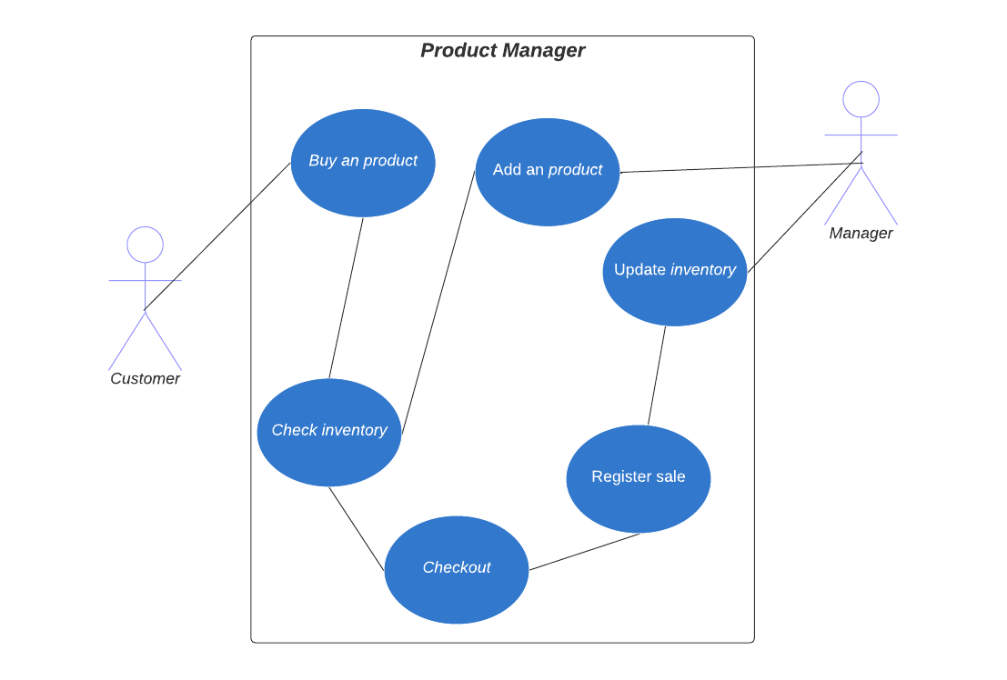

1. Context Model

صورة تحتوي على نص, رسم بياني, الخط, لقطة شاشة

تم إنشاء الوصف تلقائياً

1. Process Model

صورة تحتوي على نص, رسم بياني, لقطة شاشة, خط

تم إنشاء الوصف تلقائياً

1. Structrual model

صورة تحتوي على نص, رسم بياني, لقطة شاشة, الخط

تم إنشاء الوصف تلقائياً

1. Behavioral model

صورة تحتوي على نص, رسم بياني, رسم تقني, خطة

تم إنشاء الوصف تلقائياً

9.Tasks, Durations and Dependencies

10.Activity bar chart

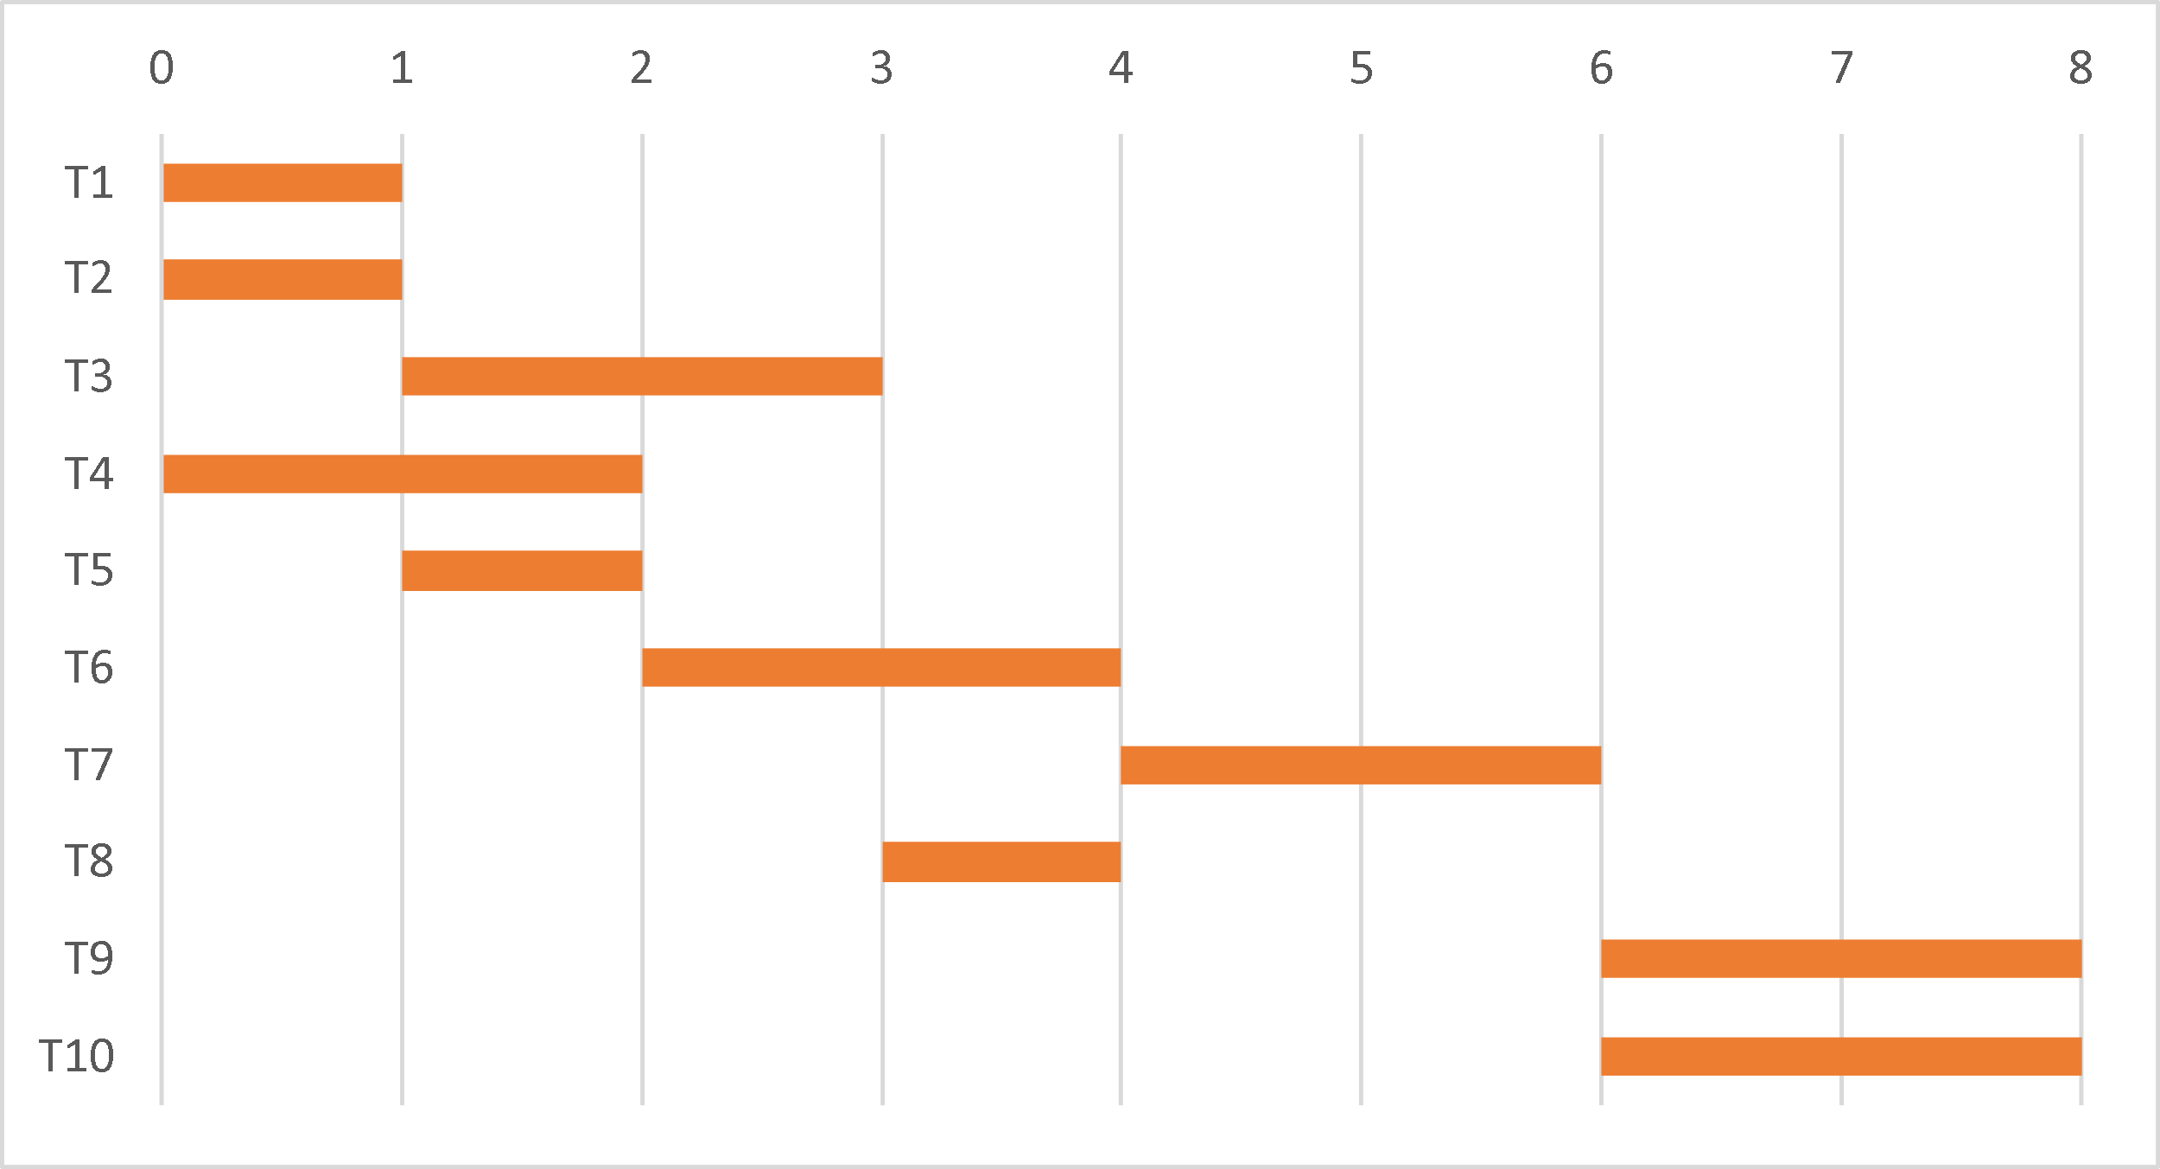

11.Staff Allocation chart

12.architecture

